Application Development Fundamentals – Answer Guide

Module 1 – Overview

Module 2 – Analysis and Design

Module 3 – Creating Application and Modules

Lab 3.1 Creating an Application

**D** — Extending a table seems like a good idea. We’ll be tracking requests and the tasks to fulfill those requests; many of these fields and features are already well-known on the Task table.

**F.3.a** — All application scopes can read, create, and update this table’s records. The ‘*Accessible from*’ field is set to ‘*All application scopes*’ by default.

**F.3.b** — Yes, the records are accessible by web services, since the ‘*Allow access to this table via web services’* box is checked by default.

**F.4** — Some of these columns, such as ‘*Created*’ and ‘*Created by*’ appear on every table. The ‘*Number*’ column is there from the ‘*Auto-number*’ option having been selected. The remainder have been inherited from the Task table.

**F.5.a** — The new role ‘loaner_request_user’ was created while in the Guided Application Creator. Furthermore. while creating the table, ‘*Create Access controls*’ was selected. When that is selected, a role is required to create the access control rules. We elected to create a new one, though an existing role could have been used.

**F.5.b** — While creating the table, ‘*Create Access controls*’ was selected.

**F.5.c** — The Application Menu and modules were created as part of the Guided Application Creator (GAC) process. When creating a table *outside* of the GAC process, you can choose whether to create a ‘*List of records*’ link type module for your new table, and whether to place it in a new or existing Application Menu.

Lab 3.2 Linking an Application

**A.7.d** – For this course, the repository branch is set to ‘*master*’. However, the default value is set to sn_instances/<instance_name>.

**A.8.a** – 3 Commits

**A.8.b** – 1 Branch

**A.8.c** – 420 KB Files

Lab 3.3 Create Application Files

**A.2 –** The Create New module opens up a Loaner Request form, and the other modules open in List view with no records.

**A.4.b** – The loaner request user role (x_cdltd_loaner_req.loaner_request_user)

**A.5.b** – No role

A.6.b – List of Records; yes – Active is True

Lab 3.4 Committing Changes to the GitLab Repository

**2.** There are a total of 6 changed files that will be committed.

Module 4 – Application Forms

Lab 4.1 Working with Fields

A**.3 —** Remove the following fields:

Parent

Priority

Active

**A.11 —** The value is low because it came from the choice list values as set for the Task [task] table.

Lab 4.2 Working with Views

**A.7.** – Self Service

**A.7.a** – No, ESS was the value entered

**A.7.b** – ESS is the name for Self Service (Title)

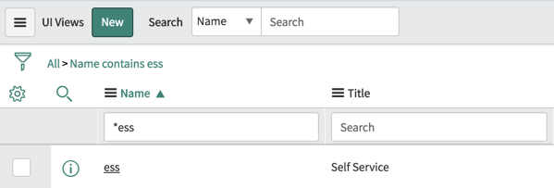

Lab 4.3 UI Policies

**E.3**- Yes, the ‘*Where will you pick up the loaner*’ message appears below the *Other* field.

**E.5**-No, we did not provide the script that undoes it.

**E.7**- Twice; No, we do not what the message to appear more than once. We need to edit the UI policy. This is what part F will cover.

**G.4** – Yes, the message goes away when a field other than ‘*Other*” is selected.

**G.5** – Yes, the message only appears once.

Lab 4.4 Scripting

**B.5.a** – If the configuration item field contains the word *Blackberry, iphone,* or *android*; the Item type field is set to ‘*Mobile Phone*’ and read-only. If the configuration item field does not contain the word *Blackberry, iphone,* or *android* then Item type is not set to read-only.

**B.5.c** - If the regular expression match method was not used, the terms would be case sensitive—i.e., ‘*iphone*’ would match, but ‘*iPhone*’ would not.

**C.3** – The ‘*location_to_be_used*’ field will populate using the values from the scratchpad.

**C.4** – *city* and *country*

**D.3.c** – Yes, the field should have the values you set for ‘*City*’ and ‘*Country code*’ in the ‘*Location to be used*’ field.

**E.3** – If the end date is before the start date an error message will appear; current.setAbortAction(true); stops the business rule and stops the system from continuing to run additional business rules.

Lab 4.6 Installing an Application

**B.6** – There are not any Loaner Request records because we did not add the data to transfer with the application files. We simply installed the application.

Module 5 – Controlling Access

Lab 5.1 Application Security

**A.2.b** - x_cdltd_loaner_req.loaner_request_user

**A.3.b** – no role (All)

**A.3.c** - x_cdltd_loaner_req.loaner_request_user (Create New); no role (Open); no

**A.4.c** – The ‘*Create access controls*’ field is not shown to be selected and is read-only. If you scroll down to the Access Controls related list, you can see the access controls.

**A.4.d** – x_cdltd_loaner_req.loaner_request_user; you can see this by opening one of the four Access Controls.

A.4.f - x_cdltd_loaner_req.loaner_request_user (create); x_cdltd_loaner_req.loaner_request_user (write); x_cdltd_loaner_req.loaner_request_user (delete); x_cdltd_loaner_req.loaner_request_user (read)

**B.5.j** – Studio does not support editing data.

|  |  |
| --- | --- |
| Application Menus | * x_cdltd_loaner_req.loaner_request_user * x_cdltd_loaner_req.admin |
| Create New | * x_cdltd_loaner_req.loaner_request_user * x_cdltd_loaner_req.admin |
| All | * x_cdltd_loaner_req.admin |
| Open | * x_cdltd_loaner_req.admin |
| Fred Luddy | * x_cdltd_loaner_req.admin |
| Abel Tuter | * None |
| Beth Anglin | * x_cdltd_loaner_req.loaner_request_user |

|  |  |  |  |
| --- | --- | --- | --- |
| User | LNR Application | Any LNR modules | LNR records |
| Abel Tuter | no | No | No |
| Beth Anglin | Yes | Yes (Create New, Open, Closed)) | If **request for** is for Beth |
| Fred Luddy | Yes | Yes (All, Open, Closed) | Yes |

After debugging the ACLs. There should be two active x_cdltd_loaner_req_loaner_request(read) ACLs:

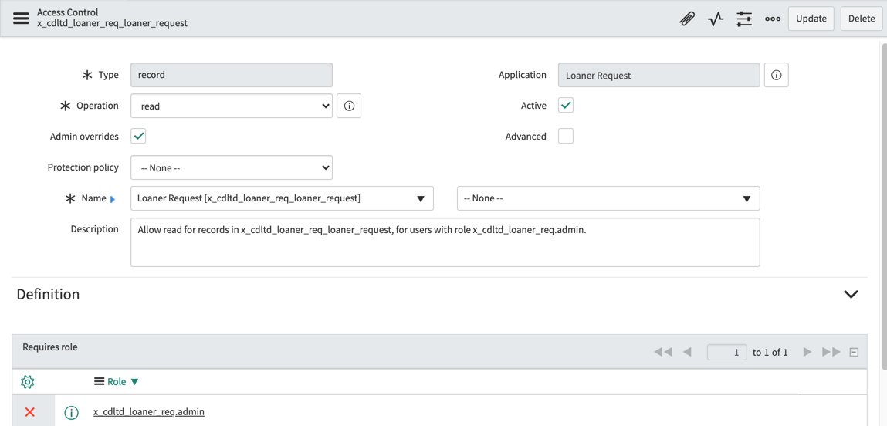

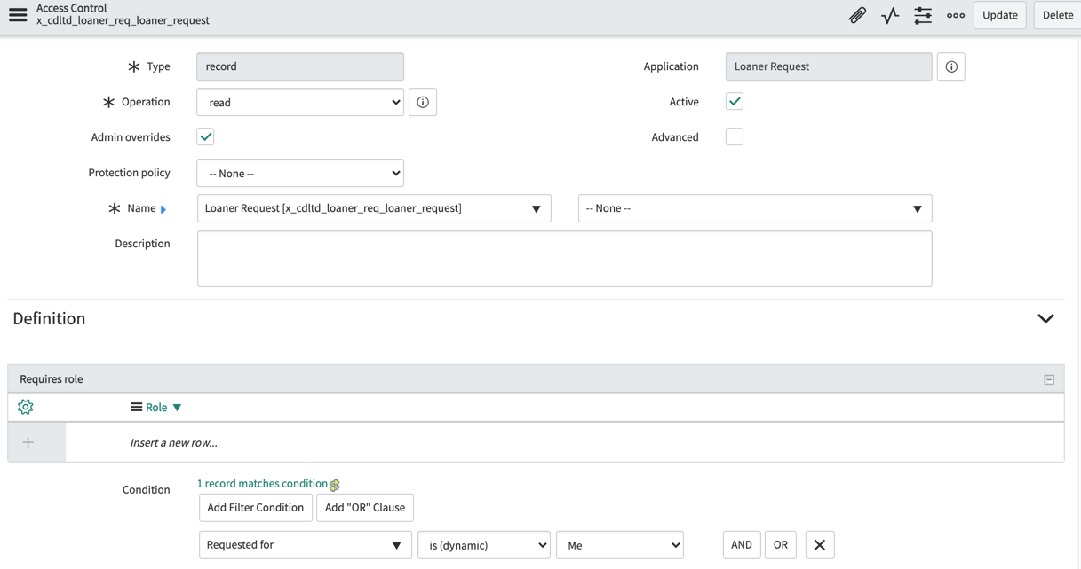

Lab 5.2 Application Access

**A.1**- x_cdltd_loaner_req_loaner_request

Module 6 – Automating Work

Lab 6.1 Flow Designer to Manage Deployment States

**I.1**- The Loaner Laptop flow is triggered when a loaner request record is created or updated and the Item type is laptop with the State of Reserved.

**I.6**- Wait For Condition; Waiting for the loaner request record’s State to be Deployment Prep (15).

\***Hint**: To complete the *Create Task* action, follow these steps:

1. **Loaner Request > Loaner Tasks**.
2. Open the Task record.

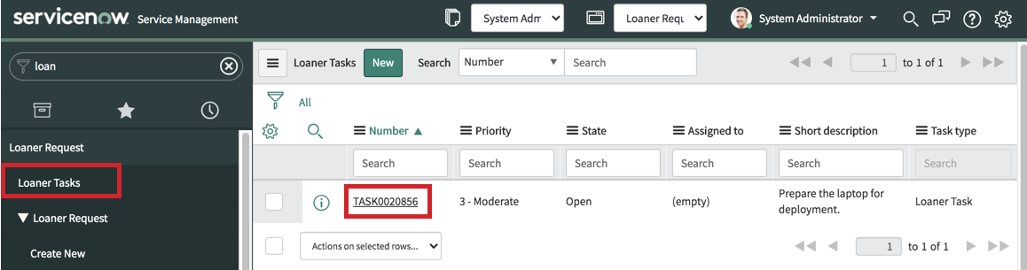

1. Change the State to **Closed Complete**.
2. **Update**.

\***Tip**: You can add the Loaner Task to the Loaner Request form:

1) Open the **Loaner Request record**.

2) Right-click the form header and select **Configure > Form Layout**.

3) Move **Loaner Task -> Parent** to the Selected slush-bucket.

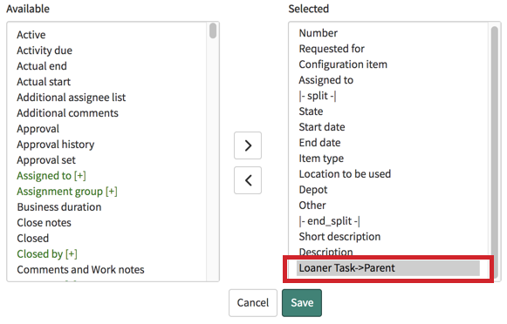

1. **Save**.

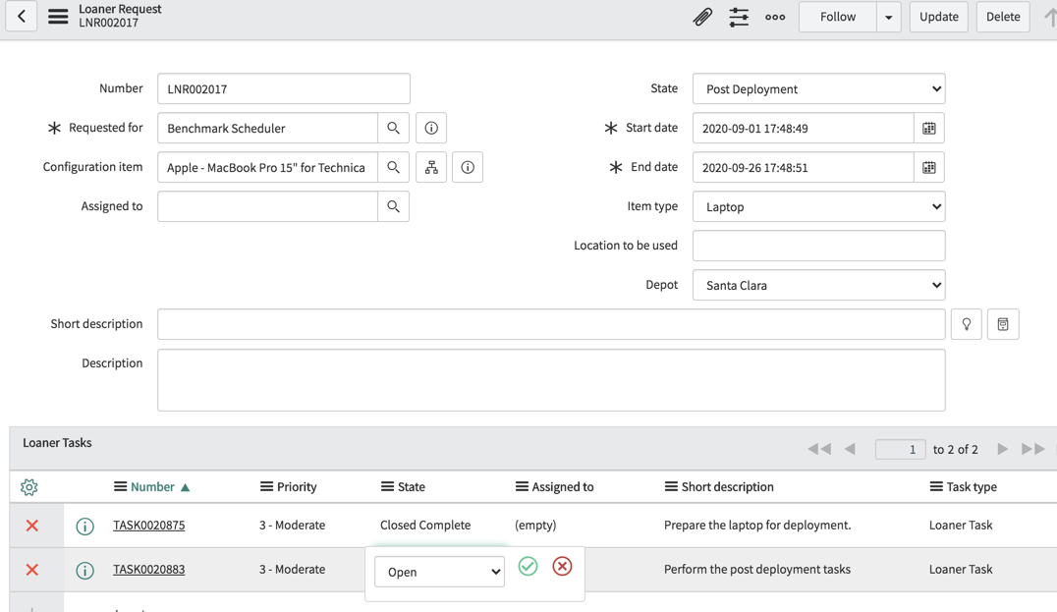

**J.5** – Yes. Since the business rule sets the state to Reserved, it will trigger the Loaner Laptop flow as long as the item type is laptop.

Lab 6.2 Creating Application Properties

**D.7**. No, Beth should not be able to see either of the modules. Beth does not have the application’s admin role.

Lab 6.3 Scheduled Script Execution and Email

**B.3** – Ready for Pickup (16)

**B.4** — The point of setting the pick_up_reminder variable in the while loop is to send a reminder for each item the borrower has requested.

**C.4** — The GlideSystem server-side API eventQueue() method standard form is gs.eventQueue(“<event_name>”, object, parm1, parm2);

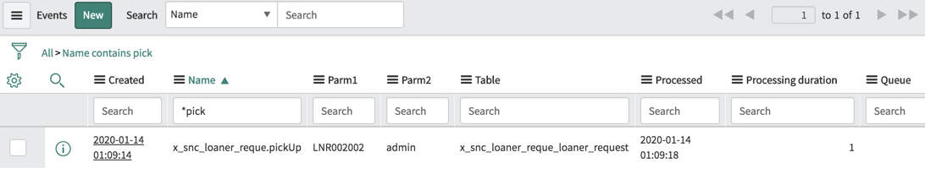

Lab 6.4 Script Include

**B.2** — This line of script grabs the value of the pickup.leadtime property (created in Lab 6.2) the moment we invoke the Script Include, and stores it into a value called *this.pickupLeadTime* which can then be used *throughout the entire Script Include’s other functions* because it was done in the initialize() function.

B.3 — As you can see in the code comments, this function gets items in State ‘*Ready for Pickup*’ that have not been announced to the requestor.

**B.4** — This function lets the requestor know they still need to pick up their item.

**B.5** — If you compare the original code in the Scheduled Script with the code in the two functions from the Script Include (*getNullPickupReminders()* and *sendPickupReminder()*), you will see they’re very similar! The Script Include is more modular, though, which is a good practice from a standpoint of maintenance and reusability. Notice that the *new* code in the Scheduled Script uses getNullPickupReminders() to do what the first ten or so lines of the original Scheduled Script do (locating Loaner Requests that need to be picked up), and then sendPickupReminder() handles the remainder. The remainder of triggering an email notification for each such Loaner Request found by the previous function.

**Module 7 – Importing and Integrating**

Lab 7.2 Web Service Consumer

D.5 — While we’ve provided the answer in the steps, if you’d like to know *why*, it’s because all the other choices are *synchronous*, and we are making a web service call through the internet to another ServiceNow instance. That could take a moment and create a perceived slowness to the application. By using an *asynchronous* call, we’re not asking the user to sit and wait for the other instance to get back to us.

Module 8 – Service Catalog

Lab 8.1 Service Catalog User Interface

**A.5** — [This is subjective.]

**B.5.c –** The fields should populate correctly.

**B.5.b** — There is not a record producer variable created to correspond to the record field ‘*Short description*’.

**C.5** — The script will set the value of the ‘*Short description*’ field on the resultant record. It sets the value as follows:

“Reservation: [item_type] from [depot]”

Additionally, the script sets the values of the ‘*Location to be used*’ and ‘*State*’ fields. Note that this aspect of record producers is great for standardizing field values!

Module 9 – Testing

Lab 9.1 Automated Test Framework

**F.9** – The test is expected to fail since the end date is before the start date.

**G.1** – The test failed at the Submit a Form due to the Set Field Values. The active business rule states the start date must be before the end date.